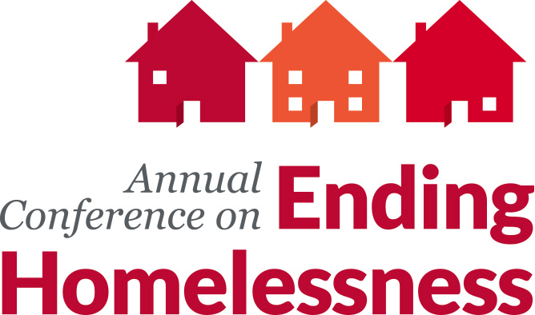
2016 Conference on Ending Homelessness
Workshop Proposal Submission Form

Section I. Workshop Submission Background Information
Thank you for your interest in presenting a workshop at the 2016 Conference on Ending Homelessness! This event will take place on May 11 and 12, 2016 in Spokane, Washington.

Please review the workshop proposal instructions before beginning your proposal application form. Detailed instructions are available at www.wliha.org/conference. Submit completed forms via email to Kate Baber at kateb@wliha.org. All proposals are due by Friday, October 30, 2015 at 11:59 PM.

Section II. Speaker Information
Each workshop will be limited to four speakers total, including moderators.

- Name (note: will be published in conference program):
Speaker 1:
Speaker 2:
Speaker 3:
Speaker 4:

- Organizational Affiliation (note: will be published in conference program):
Speaker 1:
Speaker 2:
Speaker 3:
Speaker 4:

- Title (note: will be published in conference program):
Speaker 1:
Speaker 2:
Speaker 3:
Speaker 4:

- E-mail Address:
Speaker 1:
Speaker 2:
Speaker 3:
Speaker 4:

- Phone Number:
Speaker 1:
Speaker 2:
Speaker 3:
Speaker 4:

- Mailing Address:
Speaker 1:
Speaker 2:
Speaker 3:
Speaker 4:

- Credentials (note: credentials will be published in conference program and is needed for the conference to be certified for continuing education credits, if you have any):
Speaker 1:
Speaker 2:
Speaker 3:
Speaker 4:

- Biography (note: biography will be published in conference program and is needed in order for the conference to be certified for continuing education credits):
Speaker 1:
Speaker 2:
Speaker 3:
Speaker 4:

- Is it okay for speaker e-mail address, phone number, and mailing address to be published in the conference roster and shared with other conference attendees?
Yes, it’s okay to include information on roster. No, do not include information on roster.

Section III. Workshop Information

- Workshop Title:

- Workshop length: 75 minutes 90 minutes Either

- Brief 50 words or less workshop description (note: description will be printed in the conference program):

- What is the objective or mission of your workshop?

- Please describe why the workshop presenters are qualified to present the workshop content.

- Do the presenters have any facilitation experience? If so, please describe.

- What content do you plan to cover in your workshop?

- Who will benefit from attending this workshop?

- What experience level will this workshop be geared towards?
Beginner Intermediate Advanced Expert

- What will conference attendees learn from attending this workshop?

- Will your workshop address issues unique to a specific population? If so, please describe.

- Will this workshop address racial equity or anti-oppression issues? If so, please describe.

- Why should this topic be prioritized in the conference program?

- All workshops will be tagged in the conference program to help attendees identify which workshops they are interested in attending which tags are appropriate for your workshop proposal?
Anti-Oppression
Direct Service
Emerging Advocates Program
Health Care
Housing Strategies
Organizational Development
Policy & Advocacy
Veterans
Youth & Families
Not Sure
Other (fill-in):

- What audio-visual equipment is needed for this workshop?
Computer
LCD Projector & Screen
Speakers (for playing audio clips)
Table Microphone
Internet Connection
Flip Chart with Markers (note: flip charts are not recommended in larger workshop sessions due to lack of visibility to the audience; 1 flip chart with markers will be provided in the smaller breakout session)
None

- What room set do you prefer for your workshop session (please select all that will work)? Please note the conference management team will determine room sets. We will do our best to accommodate requests, but cannot guarantee that it will be provided. Speakers will receive room set confirmations prior to the conference.
Classroom Style
Theatre Style
Round Tables
Chairs in Large Circle
No preference

- Is there anything else that you would like the conference program committee to know about your proposal?

